Assignment 4

Tianxin Zhou, [Zhou631@usc.edu](mailto:Zhou631@usc.edu)

USCID: 7402563906

**Installation**

Step 1: Install solr 8.0 on Mac OS

1. Download solr 8.0 from <http://lucene.apache.org/solr/mirrors-solr-latest-redir.html>
2. Unpack solr by using following commands:

unzip -q solr-7.7.0.zip

1. Start solr by using bin/solr start
2. Create a new core, the core name is hw4 using the command: bin/solr create –c hw4
3. solr is host on localhost:8963/solr# and can be reached by web browser
4. Go to the Solr folder which is /Users/tianxin/Downloads/solr-8.0.0 on my laptop. To change the managed-schema as in the assignment required

Step 2: Indexing

1. Download zip file from <https://drive.google.com/drive/u/0/folders/1EFkdy9cLjq0hNuC_bRQ0UO75djtvwrj7?usp=sharing>. And I downloaded Yahoo as the requirement
2. Unzip the data file and use the command: bin/post –c hw4 -filetypes html /Users/tianxin/Downloads/Yahoo/yahoo/ to indexing yahoo news html

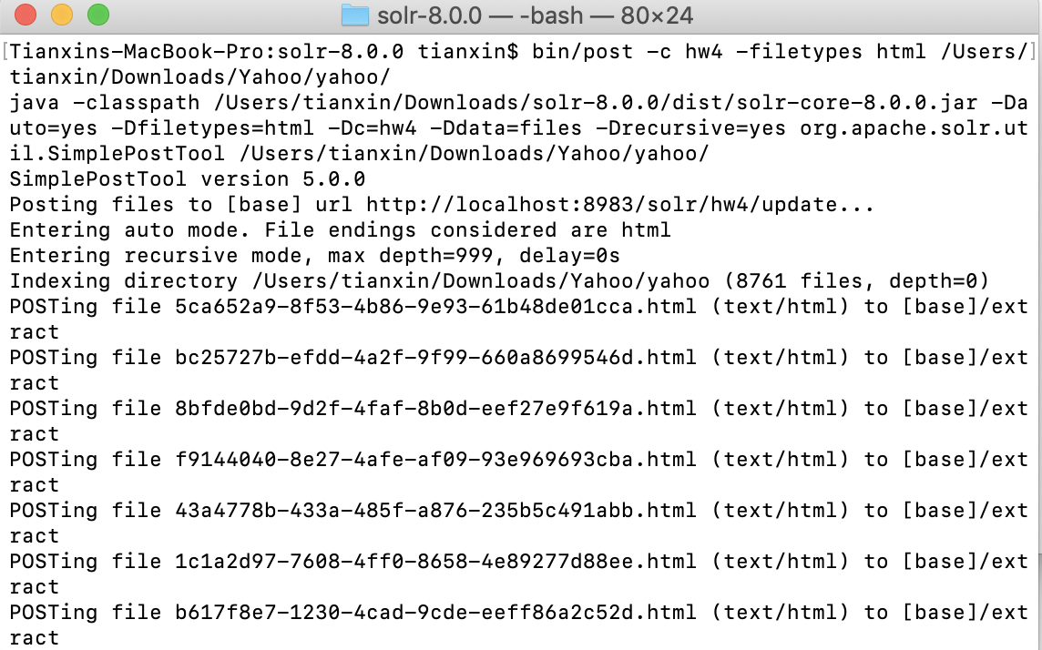

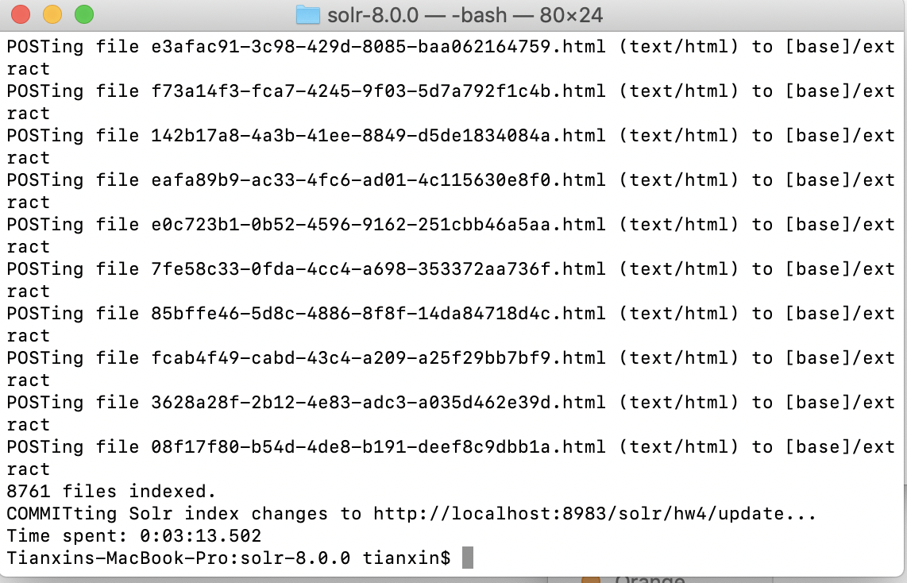

1. Go to solr admin page and reload on core dashboard.

Step 3: Setup PHP environment and application

1. Use homebrew to install [php@7.2](mailto:php@7.2) by using then command: brew install [php@7.2](mailto:php@7.2)
2. Start Apache by using command: sudo apachectl start
3. Go to /etc/apache2/ and find httpd.conf. uncomment the line: LoadModule php7_module libexec/apache2/libphp7.so
4. Start with the sample code in the assignment pdf and code for displaying url, id, title, and description. Add radio buttons for two algorithm: lucene and pageRank
5. Add additional parameters: sort => pageRankFile.txt desc for pageRank

Step 4: Generate Edge List

1. Use java to Create a directed graph using the mapping file and extracted URLs. Vertices in the graph are webpage files and detected edge between two files represent a link between two.

Use Jsoup library and URLtoHTML_yahoo_news.csv for help.

1. Generate the Edgelist.txt



Step 5: Generate external_pageRankFile.txt

1. Download and install the NetworkX from <http://networkx.github.io>
2. Write the program to computer page rank for each file by using

***G = nx.read_edgelist("edgeList.txt", create_using=nx.DiGraph())***

***PR = nx.pagerank(G, alpha=0.85, personalization=None, max_iter=30,tol=1e-06, nstart=None, weight='weight', dangling=None)***

Step 6: Modify managed-schema and solrconfig.xml

1. Open /Users/tianxin/Downloads/solr-8.0.0/server/solr/hw4/conf
2. Find the managed-schema and add

<fieldType name=”external” keyField=”id” defVal=”0” class=”solr.ExternalFileField”/> <field name=”pageRankFile” type=”external” stored=”false” indexed=”false”/>

1. Find the solrconfig.xml and add

<listener event = “newSearcher” class=”org.apache.solr.schema.ExternalFileFieldReloader”/>

<listener event = “firstSearcher” class=”org.apache.solr.schema.ExternalFileFieldReloader”/>

1. Place the external-PageRankFile.txt in data file
2. Reload hw4 core again on solr admin.

**Why some pages have higher PageRank values than others?**

Explanation:

PageRank works by counting the number and quality of links to a page to determine a rough estimate of how important the website is. PageRank assigns a score to a web paged based on the number and quality of links to or from the page. So, in our case, PageRank algorithm uses edgelist.txt to compute the PageRank values. Thus, some pages have higher values if they are pointed by other high value pages. Thus, some pages have higher PageRank values than others

**Screenshots of documenting the flow for a single query (I use Venezuela here)**

Initial page:



Result from Lucene:

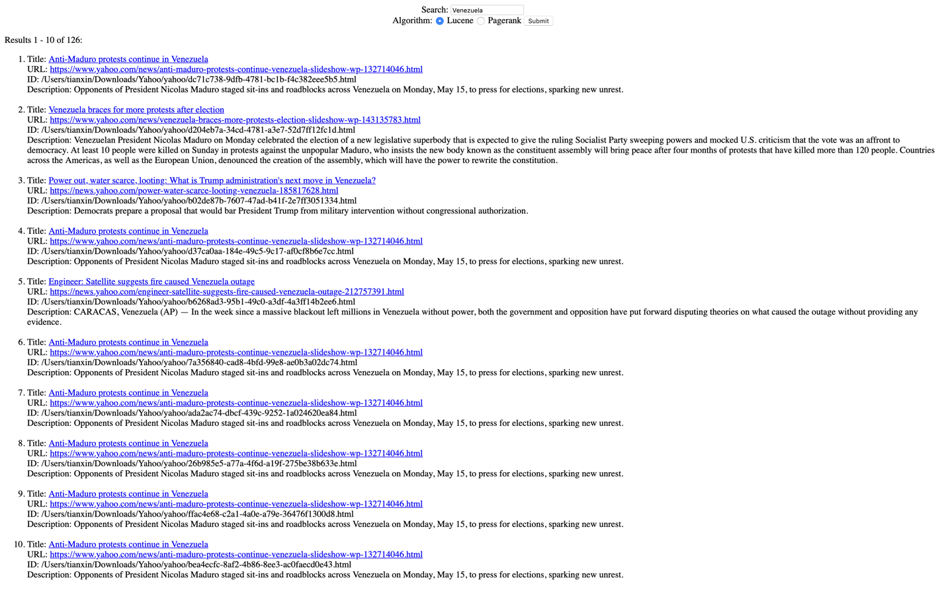

Result from PageRank:

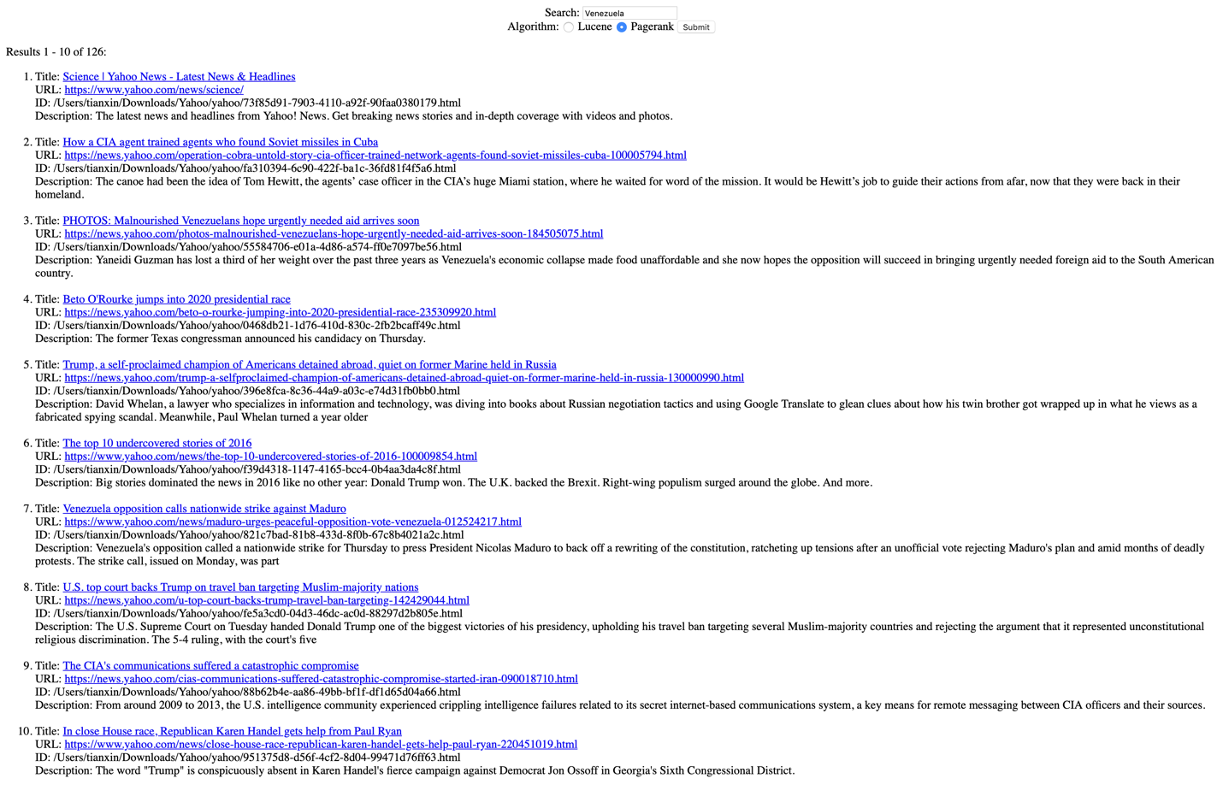

First link from Lucene result:

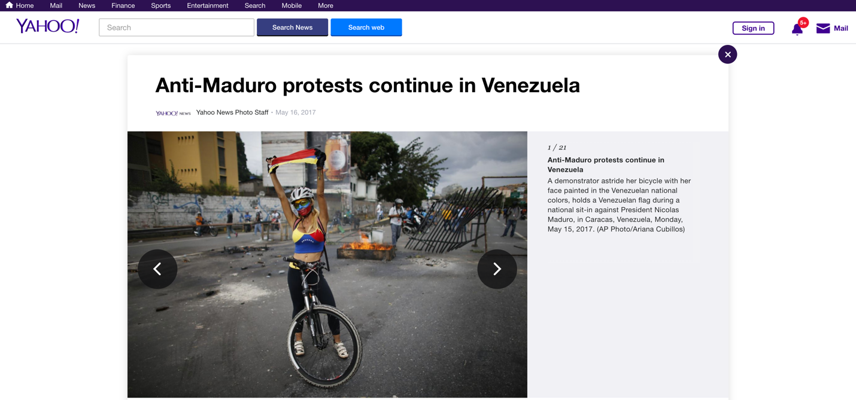

Tables of Top 10 results for each query by Lucene and PageRank

1. Venezuela

|  |  |
| --- | --- |
| Lucene | PageRank |
| https://www.yahoo.com/news/anti-maduro-protests-continue-venezuela-slideshow-wp-132714046.html | https://www.yahoo.com/news/science/ |
| https://www.yahoo.com/news/venezuela-braces-more-protests-election-slideshow-wp-143135783.html | https://news.yahoo.com/operation-cobra-untold-story-cia-officer-trained-network-agents-found-soviet-missiles-cuba-100005794.html |
| https://news.yahoo.com/power-water-scarce-looting-venezuela-185817628.html | https://news.yahoo.com/photos-malnourished-venezuelans-hope-urgently-needed-aid-arrives-soon-184505075.html |
| https://www.yahoo.com/news/anti-maduro-protests-continue-venezuela-slideshow-wp-132714046.html | https://news.yahoo.com/beto-o-rourke-jumping-into-2020-presidential-race-235309920.html |
| https://news.yahoo.com/engineer-satellite-suggests-fire-caused-venezuela-outage-212757391.html | https://news.yahoo.com/trump-a-selfproclaimed-champion-of-americans-detained-abroad-quiet-on-former-marine-held-in-russia-130000990.html |
| https://www.yahoo.com/news/anti-maduro-protests-continue-venezuela-slideshow-wp-132714046.html | https://www.yahoo.com/news/the-top-10-undercovered-stories-of-2016-100009854.html |
| https://www.yahoo.com/news/anti-maduro-protests-continue-venezuela-slideshow-wp-132714046.html | https://www.yahoo.com/news/maduro-urges-peaceful-opposition-vote-venezuela-012524217.html |
| https://www.yahoo.com/news/anti-maduro-protests-continue-venezuela-slideshow-wp-132714046.html | https://news.yahoo.com/u-top-court-backs-trump-travel-ban-targeting-142429044.html |
| https://www.yahoo.com/news/anti-maduro-protests-continue-venezuela-slideshow-wp-132714046.html | https://news.yahoo.com/cias-communications-suffered-catastrophic-compromise-started-iran-090018710.html |
| https://www.yahoo.com/news/anti-maduro-protests-continue-venezuela-slideshow-wp-132714046.html | https://www.yahoo.com/news/close-house-race-republican-karen-handel-gets-help-paul-ryan-220451019.html |

2. Senate

|  |  |
| --- | --- |
| Lucene | PageRank |
| https://www.yahoo.com/news/senate-skinny-repeal-obamacare-falls-apart-senate-floor-mccain-defects-072042708.html | https://www.yahoo.com/news/ |
| https://www.yahoo.com/news/senate-judiciary-committee-vote-kavanaugh-slideshow-wp-170920887.html | https://www.yahoo.com/news/originals/ |
| https://www.yahoo.com/news/senate-judiciary-committee-vote-kavanaugh-slideshow-wp-170920887.html | https://www.yahoo.com/news |
| https://www.yahoo.com/news/senate-judiciary-committee-vote-kavanaugh-slideshow-wp-170920887.html | https://news.yahoo.com/russians-targeted-reagan-presidential-campaign-heres-cia-stop-100048764.html |
| https://www.yahoo.com/news/jeff-session-testifies-senate-hearing-slideshow-wp-191620787.html | https://www.yahoo.com/news/politics/ |
| https://www.yahoo.com/news/protesters-across-country-oppose-gops-slideshow-wp-133309283.html | https://www.yahoo.com/news/tagged/skullduggery |
| https://www.yahoo.com/news/kavanaugh-ford-testify-senate-judiciary-slideshow-wp-145913238.html | https://www.yahoo.com/news/topics |
| https://www.yahoo.com/news/paul-ryan-premature-say-whether-house-pass-senate-healthcare-bill-174352395.html | https://news.yahoo.com/habitat-for-sale-an-oil-and-gas-group-calls-the-tune-at-the-interior-department-215244528.html |
| https://www.yahoo.com/news/cbo-likely-say-millions-lose-coverage-senate-health-care-bill-215135603.html | https://news.yahoo.com/maverick-republican-william-weld-looking-run-malignant-narcissist-trump-142709863.html |
| https://www.yahoo.com/news/trump-senate-republicans-look-like-fools-dont-dump-60-vote-rule-135937103.html | https://www.yahoo.com/news/politics |

3. Democrats

|  |  |
| --- | --- |
| Lucene | PageRank |
| https://www.yahoo.com/news/midterms/house | https://www.yahoo.com/news/ |
| https://www.yahoo.com/news/midterms/house/seat | https://www.yahoo.com/news/originals/ |
| https://www.yahoo.com/news/democrats-rolling-2018-midterms-message-next-week-191517316.html | https://www.yahoo.com/news |
| https://www.yahoo.com/news/will-democrats-filibuster-gorsuch-republicans-dont-think-so-111241581.html | https://news.yahoo.com/russians-targeted-reagan-presidential-campaign-heres-cia-stop-100048764.html |
| https://www.yahoo.com/news/white-house-tries-tag-democrats-blame-possible-shutdown-203618659.html | https://news.yahoo.com/ann-coulter-lunatic-trump-challenged-2020-right-165049018.html |
| https://www.yahoo.com/news/democrats-hope-better-deal-message-will-resonate-190849661.html | https://www.yahoo.com/news/politics/ |
| https://www.yahoo.com/news/democrats-2018-many-candidates-many-candidates-162905320.html | https://news.yahoo.com/habitat-for-sale-an-oil-and-gas-group-calls-the-tune-at-the-interior-department-215244528.html |
| https://www.yahoo.com/news/democrats-vow-fight-lifetime-keep-brett-kavanaugh-off-supreme-court-051334537.html | https://news.yahoo.com/maverick-republican-william-weld-looking-run-malignant-narcissist-trump-142709863.html |
| https://www.yahoo.com/news/mcconnell-plan-fails-will-democrats-republicans-work-together-fix-health-care-220450895.html | https://www.yahoo.com/news/politics |
| https://www.yahoo.com/news/democrats-wrest-power-away-republicans-state-level-183309710.html | https://news.yahoo.com/democrat-predicts-house-will-get-trumps-tax-returns-complications-142301949.html |

4. Republicans

|  |  |
| --- | --- |
| Lucene | PageRank |
| https://www.yahoo.com/news/midterms/house | https://www.yahoo.com/news/ |
| https://www.yahoo.com/news/midterms/house/seat | https://www.yahoo.com/news/tagged/photos/ |
| https://www.yahoo.com/news/mcconnell-plan-fails-will-democrats-republicans-work-together-fix-health-care-220450895.html | https://www.yahoo.com/news/originals/ |
| https://www.yahoo.com/news/grim-warnings-white-house-republicans-ahead-election-171354295--election.html | https://www.yahoo.com/news |
| https://www.yahoo.com/news/democrats-wrest-power-away-republicans-state-level-183309710.html | https://news.yahoo.com/russians-targeted-reagan-presidential-campaign-heres-cia-stop-100048764.html |
| https://www.yahoo.com/news/republicans-rush-obamacare-repeal-and-replace-through-house-committees-233538837.html | https://www.yahoo.com/news/politics/ |
| https://www.yahoo.com/news/gop-obamacare-replacement-narrowly-passes-out-of-committee-after-3-republicans-defect-145519718.html | https://www.yahoo.com/news/tagged/when%20presidents%20lead/ |
| https://www.yahoo.com/news/will-democrats-filibuster-gorsuch-republicans-dont-think-so-111241581.html | https://www.yahoo.com/news/tagged/skullduggery |
| https://www.yahoo.com/news/house-republicans-reveal-obamacare-replacement-bill-013510100.html | https://www.yahoo.com/news/world/ |
| https://news.yahoo.com/down-ticket-5-republicans-finally-000000015.html | https://www.yahoo.com/news/science/ |

5. Patriot Movement

|  |  |
| --- | --- |
| Lucene | PageRank |
| https://www.yahoo.com/news/jeffersons-tree-liberty-blood-schoolchildren-171918999.html | https://www.yahoo.com/news |
| https://www.yahoo.com/news/wing-patriot-prayer-rally-counter-slideshow-wp-212529094.html | https://www.yahoo.com/news/tagged/through-her-eyes |
| https://www.yahoo.com/news/wing-patriot-prayer-rally-counter-slideshow-wp-212529094.html | https://news.yahoo.com/crackdown-opioids-victims-people-need-live-100058361.html |
| https://www.yahoo.com/news/wing-patriot-prayer-rally-counter-slideshow-wp-212529094.html | https://news.yahoo.com/admissions-scam-adds-insult-injury-minority-applicants-202405114.html |
| https://www.yahoo.com/news/wing-patriot-prayer-rally-counter-slideshow-wp-212529094.html | https://news.yahoo.com/death-penalty-outlawed-203116351.html |
| https://www.yahoo.com/news/wing-patriot-prayer-rally-counter-slideshow-wp-212529094.html | https://news.yahoo.com/ilhan-omar-and-andre-carson-respond-to-horror-of-new-zealand-massacre-of-muslims-171412117.html |
| https://www.yahoo.com/news/wing-patriot-prayer-rally-counter-slideshow-wp-212529094.html | https://news.yahoo.com/latest-students-delhi-protest-cleaner-143006709.html |
| https://www.yahoo.com/news/wing-patriot-prayer-rally-counter-slideshow-wp-212529094.html | https://news.yahoo.com/photos-in-gaza-women-walk-thin-line-between-hope-and-despair-132405730.html |
| https://www.yahoo.com/news/wing-patriot-prayer-rally-counter-slideshow-wp-212529094.html | https://www.yahoo.com/news/2016-pictures-news-slideshow-wp-100040397.html |
| https://www.yahoo.com/news/wing-patriot-prayer-rally-counter-slideshow-wp-212529094.html | https://news.yahoo.com/trump-mocks-beto-o-rourkes-crazy-hand-gestures-183443014.html |

6. Oscar 2019

|  |  |
| --- | --- |
| Lucene | PageRank |
| https://news.yahoo.com/spike-lee-pushes-back-trump-spat-continues-oscar-speech-162915413.html | https://www.yahoo.com/news/ |
| https://news.yahoo.com/skullduggery-power-vice-000835154.html | https://www.yahoo.com/news/tagged/photos/ |
| https://www.yahoo.com/news/topics/star-wars | https://www.yahoo.com/news/originals/ |
| https://news.yahoo.com/trump-bashes-spike-lee-racist-hit-oscars-123716258.html | https://www.yahoo.com/news |
| https://www.yahoo.com/news/topics/royal-family | https://news.yahoo.com/russians-targeted-reagan-presidential-campaign-heres-cia-stop-100048764.html |
| https://news.yahoo.com/kamala-harris-trump-racist-185542673.html | https://news.yahoo.com/ann-coulter-lunatic-trump-challenged-2020-right-165049018.html |
| https://news.yahoo.com/the-names-behind-the-college-cheating-charges-141742295.html | https://www.yahoo.com/news/politics/ |
| https://www.yahoo.com/news/topics/technology | https://www.yahoo.com/news/tagged/when%20presidents%20lead/ |
| https://news.yahoo.com/gore-us-getting-close-political-shift-climate-change-223933667--politics.html | https://news.yahoo.com/us-grounds-boeing-737-max-amid-growing-safety-200009938.html |
| https://www.yahoo.com/news/heres-know-orlando-victims-000000001.html | https://www.yahoo.com/news/tagged/skullduggery |

7. Channel

|  |  |
| --- | --- |
| Lucene | PageRank |
| https://www.yahoo.com/news/topics/fox-news-channel | https://www.yahoo.com/news/topics |
| https://www.yahoo.com/news/topics/cnn | https://news.yahoo.com/crackdown-opioids-victims-people-need-live-100058361.html |
| https://www.yahoo.com/news/service-charlottesville-victim-heather-heyer-call-righteous-action-172114070.html | https://news.yahoo.com/operation-cobra-untold-story-cia-officer-trained-network-agents-found-soviet-missiles-cuba-100005794.html |
| https://www.yahoo.com/news/topics/megyn-kelly | https://www.yahoo.com/news/skullduggery-washington-think-tank-says-no-saudi-funds-124450269.html |
| https://www.yahoo.com/news/topics/marijuana-legalization | https://www.yahoo.com/news/topics/president-trump |
| https://www.yahoo.com/news/topics/space-exploration | https://news.yahoo.com/rory-mcilroy-blames-pga-tour-slow-play-epidemic-004543461.html |
| https://www.yahoo.com/news/topics/health | https://news.yahoo.com/the-names-behind-the-college-cheating-charges-141742295.html |
| https://www.yahoo.com/news/topics/sex-crimes | https://news.yahoo.com/death-toll-rises-nine-collapsed-lagos-school-building-074812489.html |
| https://www.yahoo.com/news/topics/sanctuary-cities | https://www.yahoo.com/news/topics/jared-kushner |
| https://www.yahoo.com/news/topics/adam-rippon | https://www.yahoo.com/news/fire-trump-says-misspoke-russian-interference-u-s-election-192113980.html |

8. Wall

|  |  |
| --- | --- |
| Lucene | PageRank |
| https://www.yahoo.com/news/wall-wall-trump-defends-border-plan-kelly-suggests-changed-145144558.html | https://www.yahoo.com/news/ |
| https://www.yahoo.com/news/imagining-trumps-big-beautiful-wall-might-183350584.html | https://www.yahoo.com/news/tagged/photos/ |
| https://www.yahoo.com/news/gop-leaders-back-at-least-12-billion-for-border-wall-153042941.html | https://www.yahoo.com/news/originals/ |
| https://www.yahoo.com/news/trumps-big-beautiful-wall-collides-congress-102804089.html | https://www.yahoo.com/news |
| https://www.yahoo.com/news/border-wall-funding-threatens-government-shutdown-budget-battle-heats-180534239.html | https://news.yahoo.com/russians-targeted-reagan-presidential-campaign-heres-cia-stop-100048764.html |
| https://www.yahoo.com/news/on-the-border-waiting-for-the-big-beautiful-wall-225959295.html | https://news.yahoo.com/ann-coulter-lunatic-trump-challenged-2020-right-165049018.html |
| https://www.yahoo.com/news/sanders-calls-obamas-400k-wall-street-speaking-fee-unfortunate-150857262.html | https://www.yahoo.com/news/politics/ |
| https://www.yahoo.com/news/steve-king-has-a-model-of-the-border-wall-he-wants-to-build-to-protect-our-superior-civilization-183248446.html | https://www.yahoo.com/news/tagged/when%20presidents%20lead/ |
| https://www.yahoo.com/news/rebuilding-great-wall-china-slideshow-wp-163045771.html | https://www.yahoo.com/news/tagged/skullduggery |
| https://www.yahoo.com/news/rebuilding-great-wall-china-slideshow-wp-163045771.html | https://www.yahoo.com/news/world/ |

**Overlap Graph:**

**0 overlap for all of queries**